NAME; AKINOLA MARY TOSIN

STUDENT ID; VEPH/20B/DA103

TECHNICAL REPORT

IMPACT OF LIFESTYLE AND HEALTH ON SLEEP DISORDERS
Outlines
- Introduction
- Story of the Data
- Data Splitting and Preprocessing
- Pre Analysis
- In Analysis
- Post Analysis and Insights
- Data Visualization and Charts
- Recommendations and Observations
- Conclusion
- References and appendices

Introduction
Sleep disorders represent a critical and growing public health concern, affecting individuals across different age groups, professions, and health conditions. Adequate sleep is essential for cognitive functioning, emotional regulation, and overall physiological well-being. However, modern lifestyle patterns characterized by high stress, sedentary behavior, irregular work schedules, and unhealthy habits have significantly contributed to the increasing prevalence of sleep-related issues.
This report explores the impact of lifestyle and health factors on sleep disorders, using a structured dataset that captures variables such as occupation, stress levels, Body Mass Index (BMI), and other behavioral indicators. The aim is to identify key drivers of sleep disorders and provide actionable insights for stakeholders in the public health sector, including healthcare providers, policymakers, and the general population.
This data was downloaded from kaggle.com
Linktothedataset; https://www.kaggle.com/datasets/uom190346a/sleep-health-and-lifestyle-dataset?

Story of the Data
The dataset used for this analysis falls within the public health domain, focusing on how individual lifestyle choices and health conditions influence sleep quality and disorder prevalence. It includes variables such as:
- Occupation (e.g., Doctors, Engineers, Lawyers, Accountants, Teachers)
- Stress Levels
- BMI Categories (Normal, Overweight, etc.)
- Sleep Disorder Presence
- Gender distribution
- Data Splitting and Preprocessing
- Data Splitting and Preprocessing
- Data Splitting and Preprocessing
- Data Splitting and Preprocessing
Data Splitting and Preprocessing
Summation of stress levels by occupation
- Count of sleep disorder cases by BMI and profession
- Gender-based comparisons
This preprocessing ensured that the dataset was suitable for both descriptive and comparative analysis.

The data reflects real-world behavioral and physiological patterns, allowing for an intersectional analysis of how professional demands, mental health strain, and physical health contribute to sleep disruptions. The dataset is particularly valuable because it captures both quantitative measures (stress levels, counts) and categorical variables (occupation, BMI classification), enabling multidimensional analysis.
The dataset underwent several preprocessing steps to ensure analytical accuracy and consistency.
First, the data was categorized into dependent and independent variables:
- Dependent Variable: Sleep Disorder occurrence
- Independent Variables: Occupation, Stress Level, BMI, Gender, and lifestyle indicators
Data cleaning
- Handling missing or inconsistent entries
- Standardizing categorical values (e.g., uniform naming of occupations)
- Grouping BMI into defined categories for clarity in analysis
Additionally, the dataset was structured to support aggregations using PivotTables, enabling:
- Summation of stress levels by occupation
- Count of sleep disorder cases by BMI and profession
- Gender-based comparisons
This preprocessing ensured that the dataset was suitable for both descriptive and comparative analysis.
Pre Analysis
Before conducting detailed analysis, initial exploration revealed several important patterns.
There was a noticeable imbalance in the distribution of occupations, with certain professions such as doctors and engineers having higher representation. Stress levels also appeared to vary significantly across professions, suggesting a potential correlation between job type and mental strain.
BMI distribution showed a concentration within the normal range, which initially challenges the assumption that sleep disorders are primarily linked to obesity. Gender distribution also indicated variations that could influence sleep patterns.
These early observations guided the analytical direction, focusing on:
- Stress as a primary variable
- Occupation as a structural determinant
- BMI as a moderating factor rather than a primary cause
Post Analysis
Following detailed analysis using PivotTables and aggregations, several strong relationships emerged between lifestyle, health, and sleep disorders.

Stress as a Primary Driver
The analysis clearly indicates that stress level is the most significant contributor to sleep disorders. Professions such as doctors recorded the highest cumulative stress levels (456), followed by lawyers and engineers. These high stress levels correspond directly with increased occurrences of sleep disorders.
This relationship highlights the physiological impact of stress, where elevated cortisol levels interfere with the body's natural sleep cycle, leading to insomnia and fragmented sleep patterns.
Occupation Based Impact
Occupation plays a critical structural role in determining sleep health. Jobs that involve:
- Long working hours
- High responsibility
- Emotional strain
tend to show higher incidences of sleep disorders.
Doctors, engineers, and lawyers consistently recorded higher disorder counts compared to professions like teachers and accountants. This suggests that work environment and job demands significantly influence sleep quality, independent of other factors.
BMI and Health Factor
Contrary to common assumptions, the analysis revealed that a large number of individuals with normal BMI also experience sleep disorders. For example:
- 65 doctors with normal BMI had sleep disorders
- 56 engineers with normal BMI were affected
This finding indicates that while BMI is relevant, it is not the dominant predictor of sleep disorders in this dataset. Instead, it acts as a secondary or interacting variable.
However, it is important to note that extreme BMI levels (especially overweight/obesity) are still medically associated with conditions like sleep apnea, even if not dominant in this dataset.
Gender Based Insights
The dataset shows a higher proportion of females within the normal BMI category. While the dataset does not directly quantify sleep disorder prevalence by gender in detail, existing patterns suggest that gender differences may influence sleep outcomes.
Females are often associated with higher reported cases of insomnia, potentially due to hormonal and psychological factors, while males may experience more physiological sleep disorders such as sleep apnea.

Data Visualization and Charts
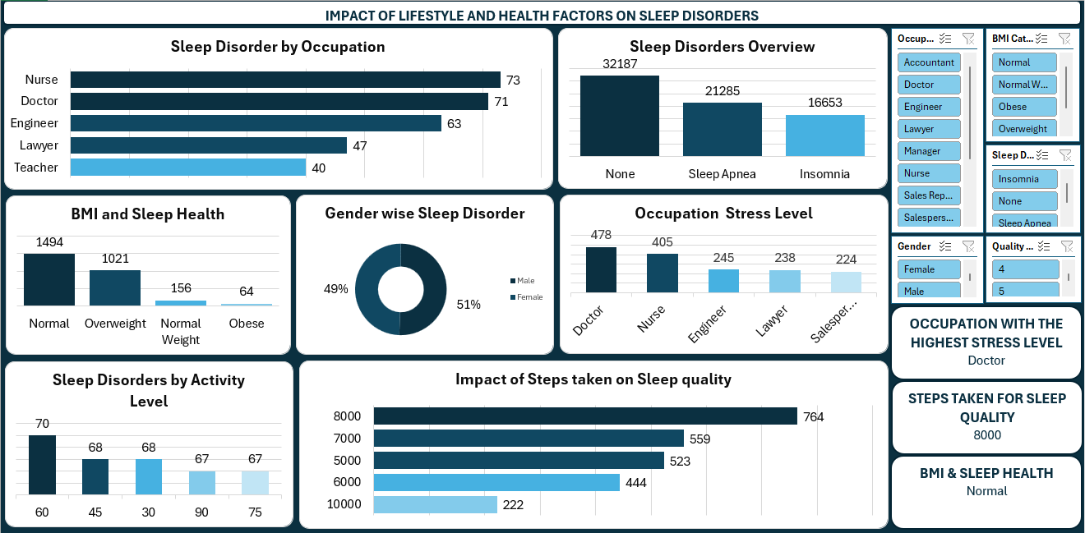
Sleep Disorder by Occupation
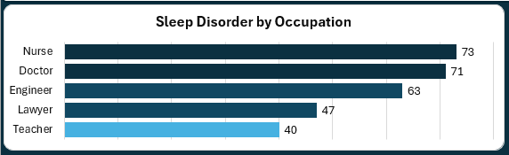
The first chart on the dashboard is a bar chart and the nurses and doctors suffer most from sleep disorders followed by engineers, lawyers and teachers

Sleep Disorders Overview
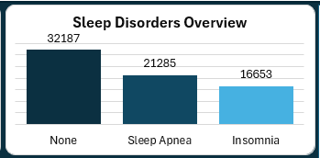
32187 individuals suffer from none, 21285 individuals suffer from sleep apnea and 16653 individuals suffer from insomnia.

BMI and Sleep Health
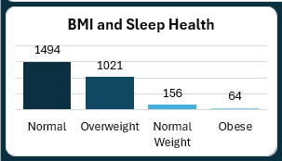
In terms of BMI, normal is 1494, overweight is 1021, normal weight is 156 and obese is 64, so normal weight tops the chart and obese is the least

Gender wise Sleep Disorder
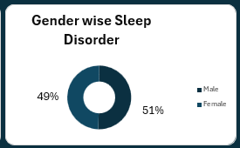
51% of male suffer from disorder while that of female is 49%, hence, male sleep disorders are slightly higher than that of the female
Occupation Stress Level
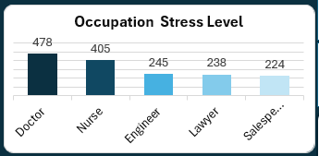
The occupation stress level is in this order, doctors, nurses, engineers, lawyers and sales person

Sleep Disorder by Activity Level
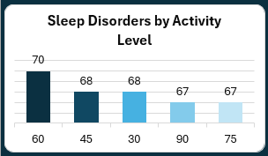
Impact of Steps Taken on Sleep Quality
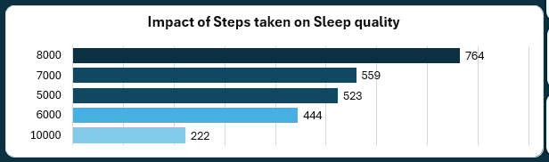
This chart shows that the best step taken to improve sleep quality is 8000 steps followed by 7000 steps.
Observations and Recommendations
Observations
The analysis demonstrates that sleep disorders are driven by a complex interaction of lifestyle and health factors, rather than a single dominant variable. Stress emerges as the most influential factor, with high-stress professions consistently showing higher disorder prevalence. Occupation further reinforces this pattern, indicating that environmental and structural work conditions significantly affect sleep health.
Interestingly, BMI does not serve as a primary predictor in this dataset, as individuals with normal BMI still exhibit high rates of sleep disorders. This challenges traditional assumptions and shifts the focus toward psychological and occupational factors.
Overall, the findings suggest that sleep disorders are multifactorial, requiring a holistic approach to understanding and intervention.
Recommendations
Based on the analysis, the following recommendations are proposed:
- Workplace Stress Management Programs
  - Organizations, especially in high-stress professions, should implement stress reduction initiatives such as counseling, flexible schedules, and mental health support.
- Awareness Campaigns on Sleep Hygiene
  - Public health bodies should educate individuals on the importance of sleep, including practices such as maintaining consistent sleep schedules and reducing screen time.
- Regular Health Monitoring
  - Routine screening for sleep disorders should be encouraged, even for individuals with normal BMI.
- Promotion of Work-Life Balance
  - Policies that limit excessive working hours can significantly reduce stress-related sleep disorders.
- Encouraging Physical Activity
  - Regular exercise should be promoted as it improves sleep quality and reduces stress.
Conclusion
This report highlights the significant impact of lifestyle and health factors on sleep disorders. The findings emphasize that stress and occupation are the primary drivers, while BMI plays a secondary role. The multifactorial nature of sleep disorders underscores the need for integrated interventions that address both psychological and physical health.
By implementing targeted strategies focused on stress reduction, awareness, and healthy lifestyle promotion, stakeholders can effectively mitigate the prevalence of sleep disorders and improve overall public health outcomes.

